**Running and Testing Chapter5Example application**

Run **mongod**:

"C:\Program Files\MongoDB\Server\3.4\bin\mongod.exe"

Run **mongo**:

"C:\Program Files\MongoDB\Server\3.4\bin\mongo.exe"

Run MongoDbCRUDTest in VS 2017.

Run Chrome browser and go to localhost:3000. The index.ejs page is displayed as shown below:

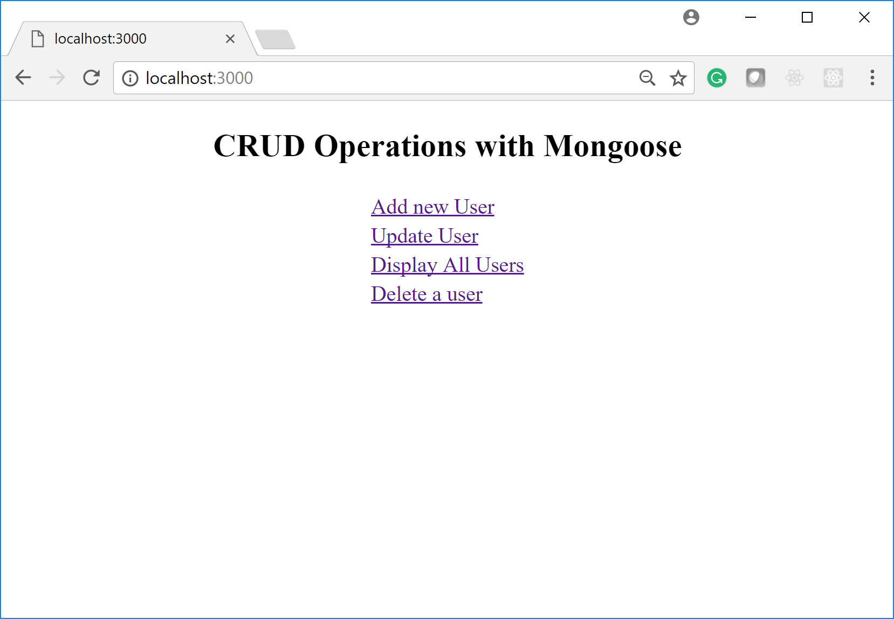

Select Add new User:

The add_user form that is displayed is already populated. Change the values of fields to new valid values as shown here:

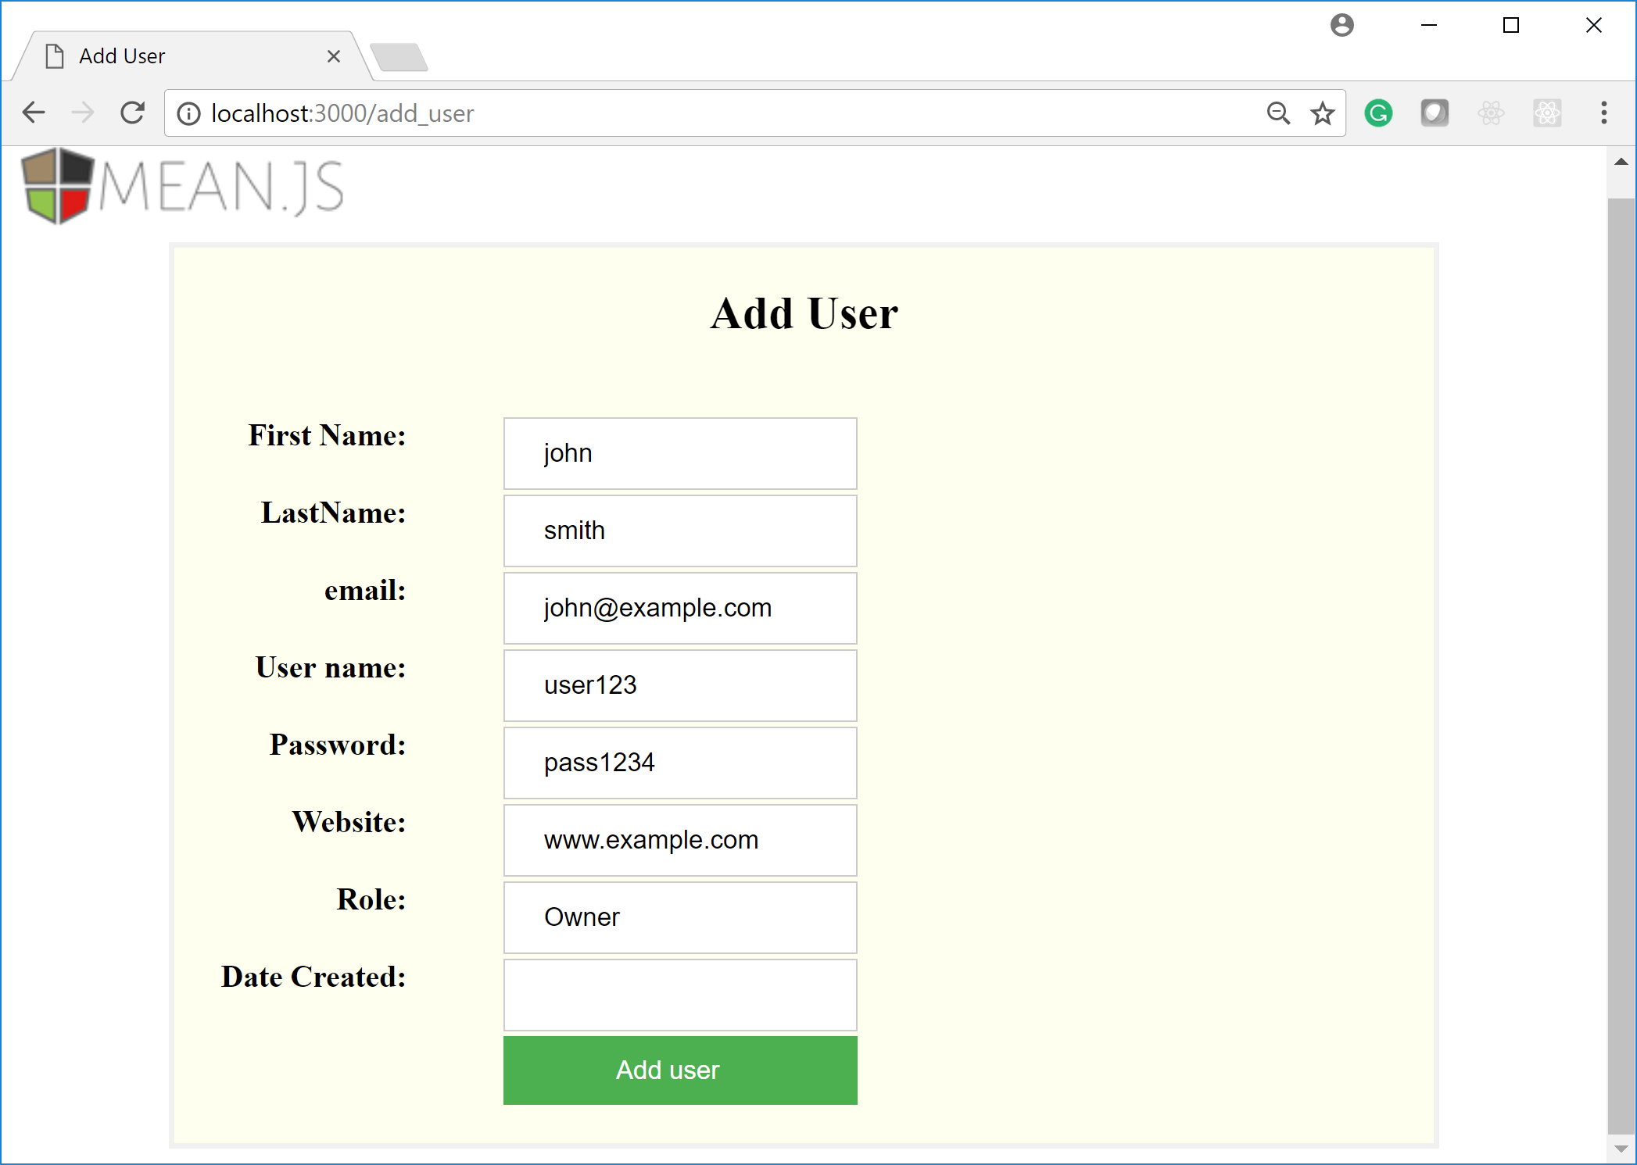

Click Add user. The application shows the new user

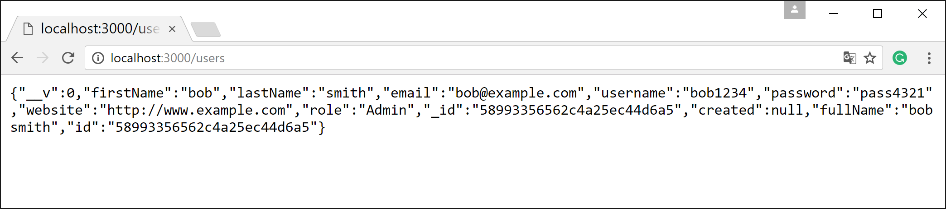

You can view all users if you press enter on <http://localhost:3000/display> link.

Go back to main page and click Update user:

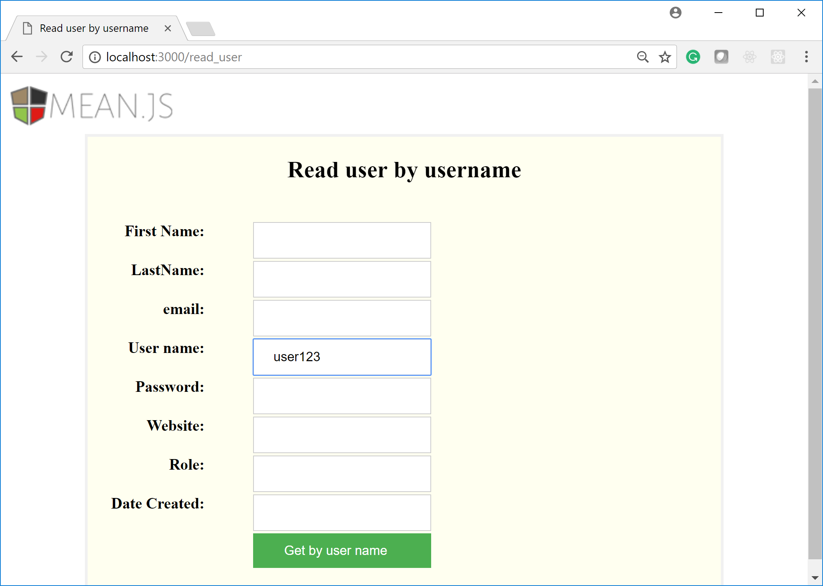

Select Update User link. Enter the username whose information will be updated. For example user123. Click Get by user name button.

The read_user page is displayed:

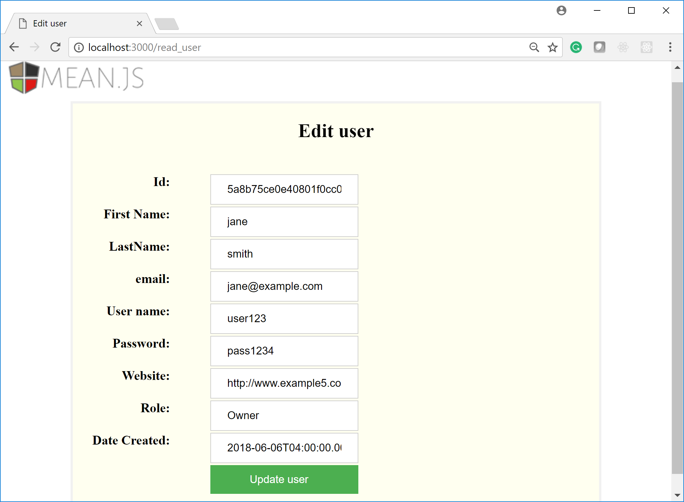

Let’s change the password to pass0101. Click Update user.

The applications shows the list of all users:

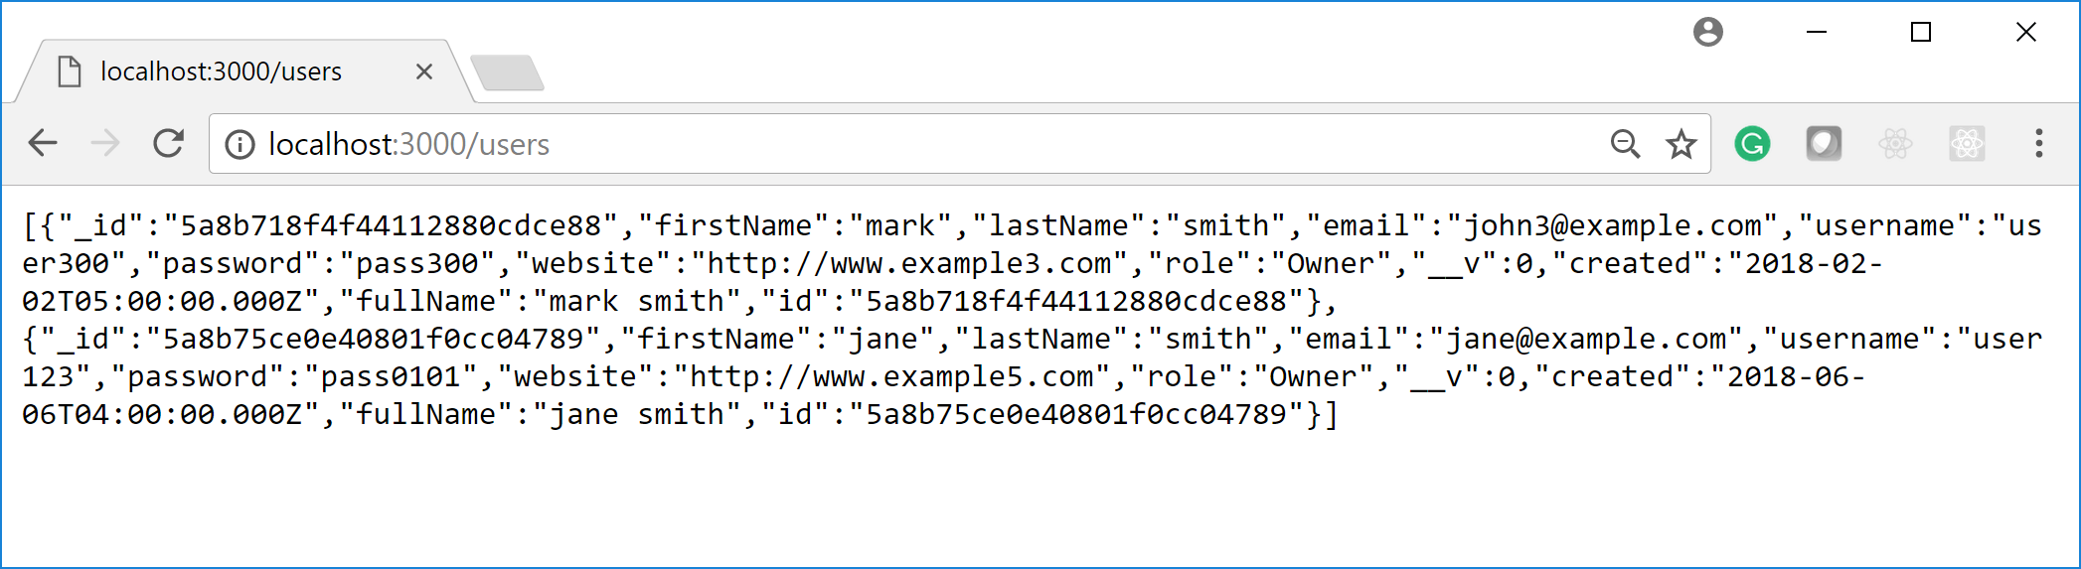

Go back to main page and test Delete user:

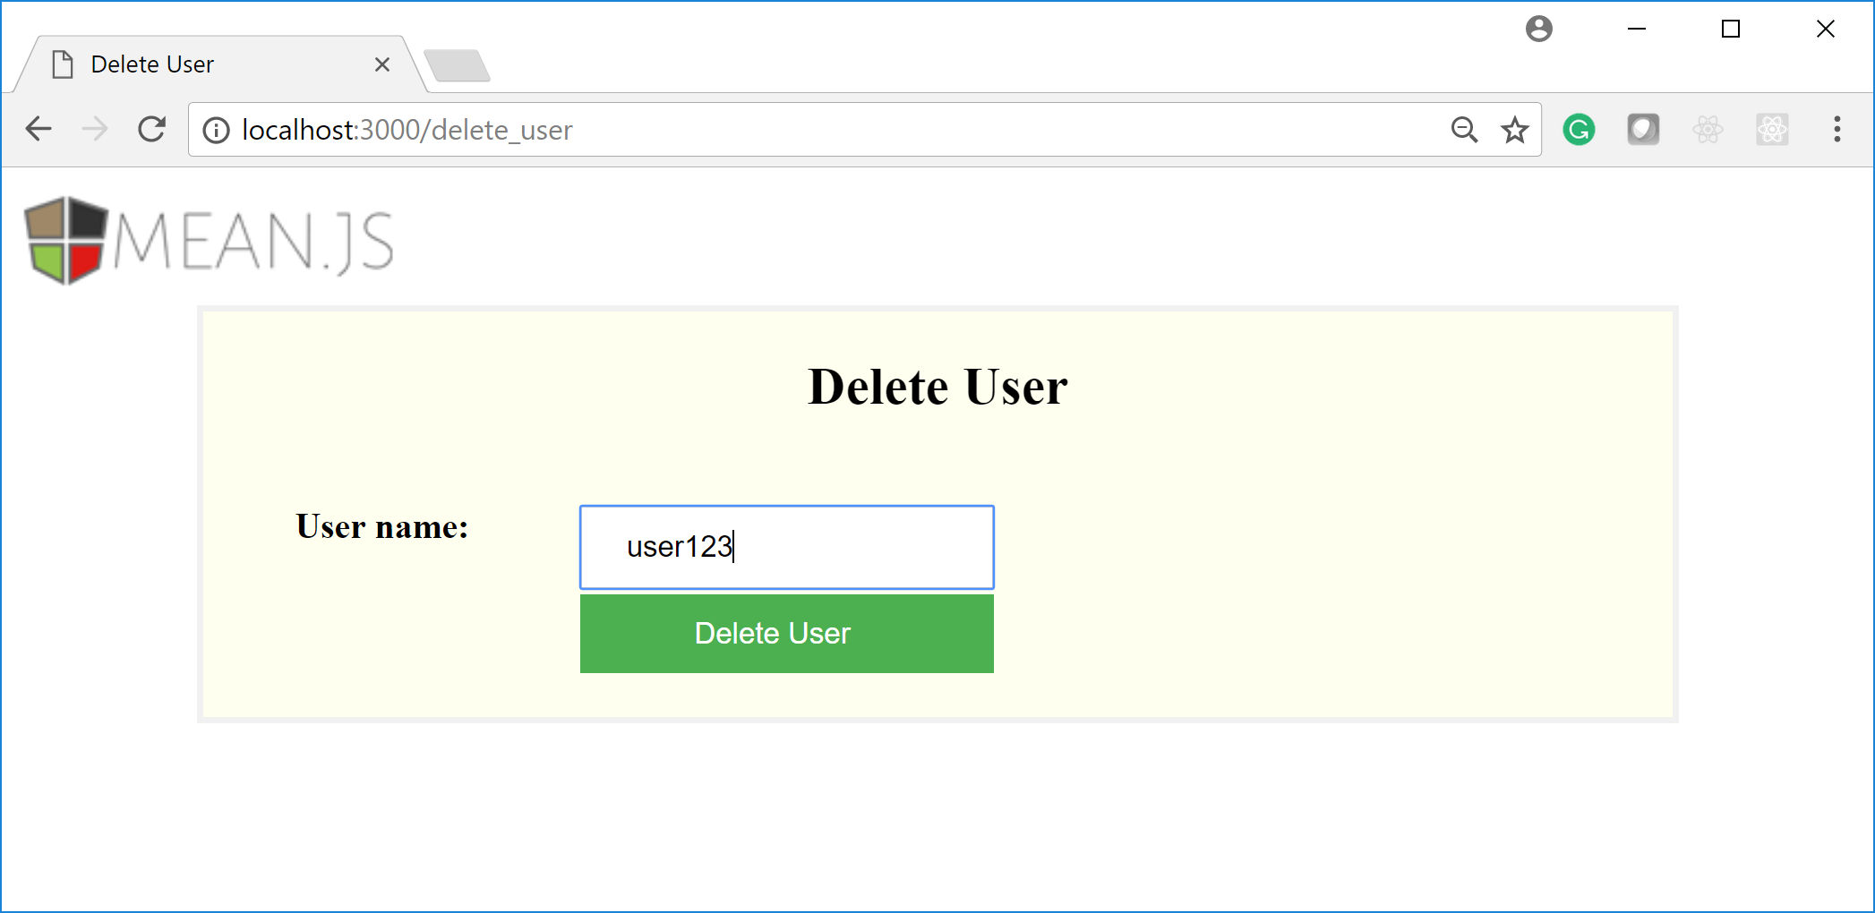

Click Delete user and check the results.